Requirements Specification (RS)
Language Learning Platform

Guilherme Junio da Silveira
6/28/25

Table of Contents
1 Introduction 4
1.1 Purpose 4
1.2 Project Scope 4
1.3 Definitions, Acronyms, and Abbreviations 4
2 User Requirements Definition 4
3 Requirements Specification 4
3.1 Functional requirements 4
3.1.1 Use Case Diagram 5
3.1.2 Requirement 1 <name of requirement in a few words> 5
3.1.3 Requirement 2 <name of requirement in a few words> 6
3.2 Non-Functional Requirements 7
3.2.1 Performance/Response time requirement 8
3.2.2 Availability requirement 8
3.2.3 Recover requirement 8
3.2.4 Robustness requirement 8
3.2.5 Security requirement 8
3.2.6 Reliability requirement 8
3.2.7 Maintainability requirement 8
3.2.8 Portability requirement 8
3.2.9 Extendibility requirement 8
3.2.10 Reusability requirement 8
3.2.11 Resource utilization requirement 8
4 GUI 8
5 System Architecture 8
6 System evolution 8

Introduction

Purpose
The purpose of this project is to develop a language-learning web application that helps users practice vocabulary and sentences using quizzes based on flashcards and spaced repetition techniques. The system is designed to adapt to each learner’s progress by adjusting the frequency of flashcards according to the user’s performance. The platform aims to provide a practical, personalized, and consistent learning experience.

Project Scope
This project will deliver a fully functional MVP (Minimum Viable Product) that allows registered users to log in, access private decks of flashcards, complete quizzes with varying difficulty levels, and receive feedback and performance analytics. The backend will be built with Java using Spring Boot, with persistent data storage in MySQL. The frontend will be simple and responsive, implemented using HTML, CSS, and Bootstrap.

Definitions, Acronyms, and Abbreviations
MVP: Minimum Viable Product
CRUD: Create, Read, Update, Delete
UI: User Interface
UX: User Experience
API: Application Programming Interface
MySQL: A relational database management system
Spring Boot: A Java-based framework for backend development
Spaced Repetition: A learning technique that increases intervals of time between reviews of previously learned material

User Requirements Definition
The system is intended for individual language learners who want to improve their vocabulary and language structure through regular practice. Users need a platform that adapts to their learning pace, tracks their progress, and makes studying more consistent and engaging.
The main user requirements are:
- The user must be able to create an account and log in securely.
- The user should be able to select a deck and start a quiz.
- The quiz should present flashcards based on difficulty and user history.
- After answering, the user should be able to rate how easy or hard the flashcard was.
- The system should update the flashcard’s repetition frequency based on the user’s rating.
- Users should be able to see a summary of their performance after each quiz.
These requirements are meant to ensure that the application is practical, user-friendly, and effective for independent language learning.

Requirements Specification

Functional requirements

Use Case Diagram
The Use Case Diagram provides an overview of all functional requirements.
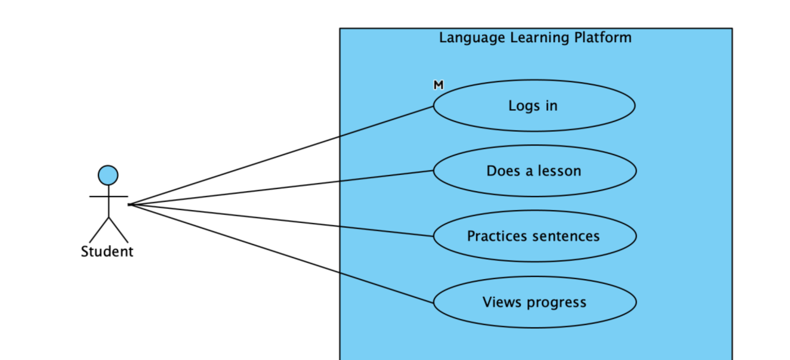

Requirement 1 – Practice Flashcards

Description & Priority
This requirement allows users to practice flashcards from a selected deck. Each flashcard is displayed one at a time, allowing the user to flip it to view its translation. The user then rates their familiarity with the flashcard. These ratings are recorded and used to update the order of appearance based on user performance, supporting the spaced repetition method.
Priority: High

Use Case
Scope: Flashcard Quiz Functionality
Description: This use case describes the process in which a logged-in user engages in a flashcard quiz session using a selected deck.
Primary Actor: Registered User (Student)
Preconditions:
- User must be logged in.
- At least one deck of flashcards must be available and selected.
Main flow
- System presents the first flashcard.
- User flips the flashcard to see the translation.
- User selects a rating: Easy, Medium, Hard, or Don’t Know.
- System records the rating and reorders the deck dynamically.
- Steps 1-4 repeat until all flashcards are reviewed or session ends.
- System displays a summary of the user’s performance.
Alternate flow
A1: If the user decides to skip a flashcard
- System records it as “Skipped” and presents the next flashcard
Exceptional flow
E1: If no flashcards exist in the selected deck
- System shows an error message and redirects the user to deck selection.
Post conditions
- User ratings are stores and linked to the corresponding flashcards.
- Flashcard priority and repetition logic are updated based on user feedback.
- Session summary is stored for analytics.

Requirement 2 – Rate Flashcards and Adjust Repetition Frequency

Description & Priority
The system must allow users to rate each flashcard based on their understanding (Easy, Medium, Hard, or Don’t Know). These ratings will influence how frequently each card appears in future sessions. Cards marked as difficult or unknown will appear more often, while easier ones will be shown less frequently over time, reinforcing the spaced repetition model.
Priority: High

Use Case
Scope: Adaptive Learning Functionality
Description: This use case outlines how flashcard ratings are used to adjust the scheduling of future reviews.
Primary Actor: Registered User (Student)
Preconditions:
- User must be logged in.
- The flashcard must have been flipped (reviewed).
Main flow
      - The user selects a rating (Easy, Medium, Hard, Don’t Know).
      - The system records the rating and uses it to update the card’s priority in the learning queue.
      - The session continues with the next flashcard.
Alternate flow
A1: If the user closes session early:
1. Ratings for already-reviewed flashcards are saved.
2. The session can be resumed later from the last reviewed card.
Exceptional flow
E1: If a card fails to load or is incomplete:
- System skips the card and logs an error.
- The user is notified and taken to the next card.
Post conditions:
- Rating is saved and associated with the specific flashcard and session.
- Card scheduling logic is updated in the backend.

Requirement 3 – User Authentication

Description & Priority
Users must be able to register and log in securely to the system. Only authenticated users will be able to access their personalized flashcard decks, practice history, and performance analytics. This helps ensure data privacy and enables user-specific learning progress tracking.
Priority: High

Use Case
Scope: Account Management
Description: This use case allows a user to register for an account or log in to access personalized features.
Primary Actor: Student
Preconditions:
- For login: Account must already exist.
- For registration: Valid email and password must be provided.
Main flow - Registration
- User clicks “Register” on the homepage.
- User enters email and password.
- System validates input and creates the account.
- System logs the user in and redirects them to the dashboard.
Main flow - Login
- User clicks “Login” on the homepage.
- User enters email and password.
- System verifies credentials.
- If correct, user is logged in and redirected to the dashboard.
Alternate flow
A1: If the user enters incorrect password:
1. System displays an error message and prompts to try again.
Exceptional flow
E1: If email is not registered:
- System informs the user and suggests account creation.
Post conditions:
- Authenticated session is started.
- User is redirected to the dashboard.

Requirement 4 – View Performance Statistics

Description & Priority
The system should display personalized performance analytics to help students understand their learning progress. This includes statistics such as quiz accuracy, flashcard difficulty trends, most missed items, and overall improvement over time.
Priority: Medium

Use Case
Scope: Analytics and Feedback
Description: This use case allows students to visualize their progress and identify areas for improvement.
Primary Actor: Student
Preconditions:
- User must be logged in.
- The user must have completed at least one quiz of flashcard session.
Main flow
- User logs in and access the dashboard.
- User clicks “My Performance”.
- System retrieves historical data related to quiz and flashcard activity.
- System displays charts and indicators showing accuracy rates, difficulty breakdown, and progress trends.
Alternate flow
A1: If no activity is recorded yet:
1. System shows a message like “Start your first session to see progress here”.
Exceptional flow
E1: If data retrieval fails due to server error:
- System displays a message and suggests retrying later.
Post conditions:
- The system displays performance statistics retrieved from the database.

Requirement 5 – Manage Flashcard Decks

Description & Priority
Only authorized admins or system managers should be able to create, edit, or delete flashcard decks and the flashcards within them. This ensures content quality and prevents unauthorized changes to educational material. Students will only be able to view and interact with the decks assigned to them.
Priority: Medium

Use Case
Scope: Content Management
Description: This use case describes how an admin manages the flashcard decks and their content.
Primary Actor: Admin
Preconditions:
- Admin must be logged in.
Main flow – Create Deck
- Admin logs in and access the deck management page.
- Admin clicks “Create New Deck”.
- Admin provides a name and category.
- System stores the new deck.
Main flow – Add/Edit/Delete Flashcards
- Admin selects a deck.
- Admin clicks to add, edit, or delete a flashcard.
- Admin fills in the sentence and translation fields as needed.
- System saves the changes and updates the deck contents.
Alternate flow
A1: Admin cancels the operation:
1. System discards changes and returns to the deck overview.
Exceptional flow
E1: If fields are invalid (e.g., empty or duplicate):
- System displays an error and prevents saving.
Post conditions:
- Changes to decks or flashcards are reflected in the system and available to students for practice.

Non-Functional Requirements

Performance Requirements
The system should deliver responses to user actions, such as loading quizzes or submitting answers, within 2 seconds under normal network conditions. The backend should support at least 50 concurrent users without significant performance degradation.

Availability requirement
The system should be available at least 95% of the time, excluding maintenance periods. In case of server downtime, users should be shown a friendly maintenance message.

Security Requirements
User data must be protected through secure authentication mechanisms and encrypted password storage. Only authenticated users can access practice history and personal analytics. Admin operations (e.g., managing decks) must be restricted to authorized roles.

Maintainability requirement
The system codebase should follow modular and well-documented practices, allowing future contributors to add features or fix bugs with minimal ramp-up time. Use of standard frameworks like Spring Boot and RESTful APIs ensures maintainability.

Usability Requirement
The interface should be intuitive and accessible to language learners of different levels. A responsive layout is required so users can access the system comfortably from desktops, tablets, or smartphones.

Interface requirements

User Interfaces
The system will provide a clean, responsive web interface designed primarily for students. Key interface elements will include:
Login/Register page: Secure authentication for students and admins.
Dashboard: Overview of recent activity, available quizzes, and performance summary.
Quiz page: Interactive layout to answer sentence-based flashcards with difficulty rating.
Performance page: Displays user statistics such as accuracy and progress over time.
Admin panel (restricted): For creating, editing, and deleting decks and flashcards.

The UI will be developed using HTML, CSS, and optionally Bootstrap, and rendered via Spring Boot using simple templating or server-side rendering.

Hardware Interfaces
No special hardware is required. The application will be accessible via modern web browsers on common devices such as:
- Desktop computers (Windows, macOS, Linux)
- Tablets and smartphones (iOS, Android)

Software Interfaces
Frontend: HTML/CSS/Bootstrap
Backend: Java with Spring Boot (RESTful API)
Database: MySQL for persistent storage of user data, quizzes, flashcards, and results
Development Tools: Visual Studio Code, Visual Paradigm, MySQL Workbench, Trello
Security: Spring Security (planned for role-based access and login authentication)

Communication Interfaces
The system will follow the client-server model:
- HTTP/HTTPS requests between the client interface and the Spring Boot backend
- JSON format for communication between frontend and backend
- JDBC or Spring Data for communication between the backend and MySQL database

System Evolution
This section describes how the system could evolve over time.
This system could allow future enhancements without major structural changes. Possible improvements include adding teacher accounts to manage students, implementing gamification features to increase engagement, supporting audio-based exercises for listening and pronunciation, and eventually developing a mobile app. These additions aim to make the platform more interactive, accessible, and adaptable to different learning needs.

